

**AMERICAN INTERNATIONAL UNIVERSITY-BANGLADESH**

**Final-Term Project Report**

***A train as a transport system of AIUB students***

**Computer Graphics**

**Section: F**

**Group No-03**

**Summer, 2020-21**

Submitted to:

**Course Teacher:** Aneem Al Ahsan Rupai

Lecturer, Computer Science

Submitted by:

|  |  |
| --- | --- |
| **Members** | |
| Mushfiq Qayyum | 17-33170-1 |
| Shawon,Bm Rahful Hasan | 18-38270-2 |
| Pulack Chakrabortty | 18-37264-1 |
| S.M. Fardin Hossain | 17-34494-2 |

* **Table of Contents**

***Content Name***  ***Page No***

* **Introduction ------------------------------------------------------------------------------- 2**
* **Proposal -------------------------------------------------------------------------------------2**
* **Schematic Diagram -----------------------------------------------------------------------3**
* **List of Objects ------------------------------------------------------------------------------4**
* **Functions to represent the objects --------------------------------------------------4**
* **Interactive functions --------------------------------------------------------------------5**
* **Task Assignment ------------------------------------------------------------------------ 5-6**
* **Conclusion ---------------------------------------------------------------------------------6**
* **Introduction**

We did our project by using Code Blocks IDE. To access the code blocks graphics library, we used OpenGL API. By using the API, we are using the GL/glut.h library. All these tools help us to make our project. Basically, we apply our lab task knowledge to this project and that actually works.

* **Proposal**

There will be a train as a transport system of AIUB students. There will be also a junction in front of AIUB main gate from where the train will start and stop. We have mainly created some artifacts in this mini project, like a aiub station, sun,moon, clouds, trees, Bridge, train  etc.In the project a small junction in aiub scenery is presented. . The sky is cloudy and sun shines. When the train reaches to the junction, then the sun sets and evening falls and after a while the it becomes night. The night sky is full of stars and a large moon appears on the left side of the window screen. We can also increase the speed of the train. It has also got two modes in it, day mode and the nightmode. The above-explained things are attained in the day mode and in the night mode there will be moon and stars in the sky.This is an overview of the project.

**Scenarios**

* Running train on bridge
* Train reaches to the junction
* Day to night transition

**Schematic Diagram**

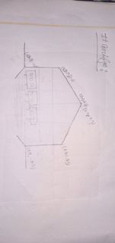

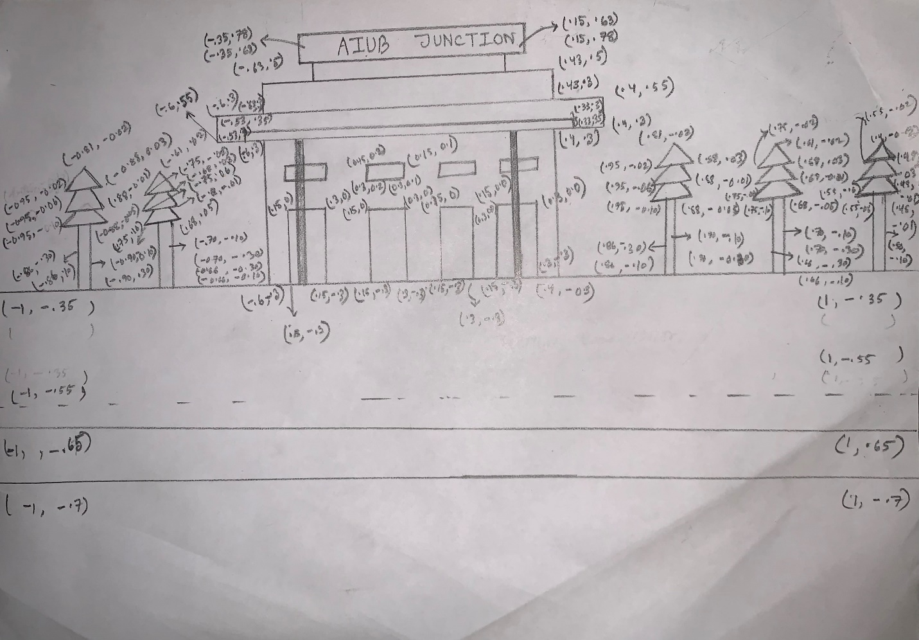

* **List of Objects**
* A train
* AIUB Junction
* Bridge
* River
* Rail line
* Clouds
* Sun
* Moon
* Starts
* **Functions to represent the objects**

|  |  |  |
| --- | --- | --- |
| **ID NO** | **Object Name** | **Function Name** |
| 1 | Text | void Text() |
| 2 | background | void background() |
| 3 | background_afternoon | void background_afternoon() |
| 4 | background_night | void background_night() |
| 5 | Stars | void stars() |
| 6 | cloud1 | void Update_cloud1() |
| 7 | cloud2 | void Update_cloud2() |
| 8 | Station | void station() |
| 9 | Sun | void sun() |
| 10 | Moon | void moon() |
| 11 | wheels | void wheels() |
| 12 | Train | void train() |
| 13 | Train_night | void train_night() |
| 14 | Bridge | void bridge() |
| 15 | Night view | void night() |
| 16 | Afternoon view | void afternoon() |
| 17 | Day | void day() |
| 18 | Text1 | Void text1() |
| 19 |  |  |
| 20 |  |  |

* **Interactive functions**

|  |  |  |
| --- | --- | --- |
| **ID No** | **Interactive Function Name** | **Object Name** |
| 21 | void display_day(int a); | Day |
| 22 | void display_night(int b); | Night |
| 23 | void display_afternoon(int c); | Afternoon |
| 24 | void update(int value) | Train |
| 25 | void handleKeypress(unsigned char key, int x, int y) | Keyboard Interaction to increase the train speed |
| 26 | Void Update_cloud1() | Cloud-1 |
| 27 | Void Update_cloud2() | Cloud-2 |
| 28 | void train_night() | Train night view |
| 29 |  |  |
| 90 |  |  |

* **Task Assignment**

|  |  |  |
| --- | --- | --- |
| **Contributor Name: Mushfiq Qayyum** | | |
| **Object Functions** | **ID NO** | **Function Name** |
| 12 | Void train() |
| 18 | Void text1() |
| 11 | void wheels() |
| 13 | void train_night() |
|  |  |
|  |  |
|  |  |
| **Interactive Functions** | 24 | void update(int value) |
|  |  |
|  |  |

|  |  |  |
| --- | --- | --- |
| **Contributor Name: Shawon,Bm Rahful Hasan** | | |
| **Object Functions** | **ID NO** | **Function Name** |
| 6 | void Update_cloud1() |
| 7 | void Update_cloud2() |
| 14 | void bridge() |
| 9 | void sun() |
| 10 | Void moon() |
|  |  |
| **Interactive Functions** | 26 | Void Update_cloud1() |
| 27 | Void Update_cloud1() |

|  |  |  |
| --- | --- | --- |
| **Contributor Name: Pulack Chakrabortty** | | |
| **Object Functions** | **ID NO** | **Function Name** |
| 2 | void background() |
| 3 | void background_afternoon() |
| 4 | void background_Night() |
| 17 | void Day() |
| 15 | void Night() |
|  |  |
|  |  |
| **Interactive Functions** | 21 | void display_day(int a); |
| 22 | void display_night(int a); |
| 23 | void display_afternoon(int c); |

|  |  |  |
| --- | --- | --- |
| **Contributor Name: S.M. Fardin Hossain** | | |
| **Object Functions** | **ID NO** | **Function Name** |
| 1 | void text() |
| 8 | void station() |
| 5 | void stars() |
| 16 | void afternoon() |
|  |  |
|  |  |
| **Interactive Functions** | 25 | void handleKeypress(unsigned char key, int x, int y) |
| 28 | void train_night() |

* **Conclusion**

This project is one of the sample project on Computer Graphics. Though many difficulties were faced during the project as well as many errors occurred, we became succeed to com-pile and run the program. There may be some limitations on this project as well, so, in the near future we would like to be hopeful in further improvements. We are highly obliged to all helping hands and to all inspirations to make this project successful. Well this project will be applicable to most of all. As well as, we are more hopeful for more advice, new ideas and inspiration to make more other projects. In this project, we applied our all knowledge and idea which we are learned from the lab class and the lab task. We tried our best to make this project standard and realistic.